1.2 Item-level access (Warehouse, Lakehouse & Notebook)

Key points
- If you don't want to give people access to EVERYTHING in a workspace, you can give people more granular item-level access. This is available for nearly all Fabric items, apart from Data Pipelines, and Dataflows.

- Each item has a slightly different set of sharing permissions.

- The person (or group) you give item-level access will be able to access the item via the OneLake data hub.

- To use the Data Warehouse as an example, when you share a Warehouse, at the item-level, it looks like this:
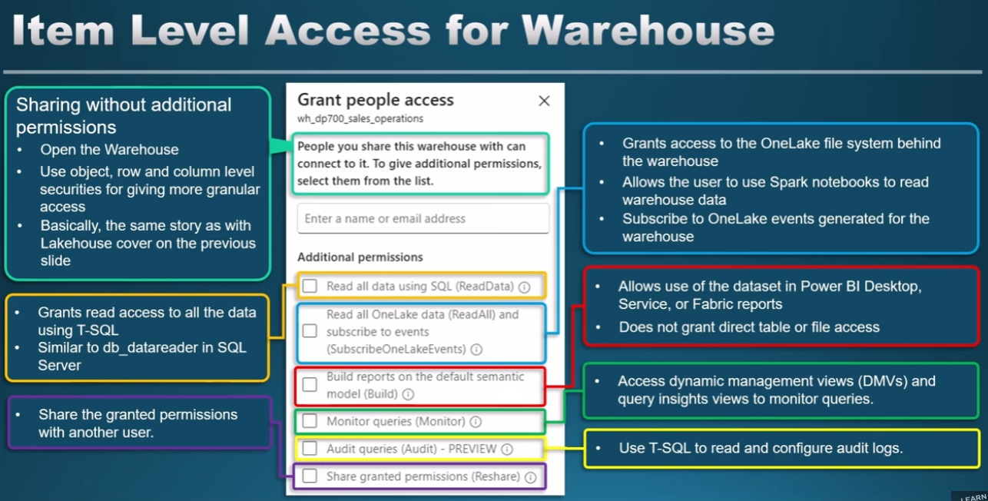

Different permissions levels, when sharing a Warehouse:
- Read permission: If you don't tick any of the additional permissions boxes, you will give the user/ group READ access to the Warehouse. This means, they will be able to access the Warehouse via the OneLake data hub, but they will not be given any access to tables in the Warehouse. This is useful when you want to assign this user/group granular permissions, such as object-level security.

- ReadData permission: if you tick the first permission box, you will give ReadData permission, this will give the user/ group read-access to all tables within the Warehouse (via the T-SQL endpoint).

- ReadAll permission: if you tick the second permission box, you will give ReadAll permission. This will allow the user/ group read permissions to the underlying OneLake files, meaning they can access the data from other engines (e.g. Spark)

- Build permission: gives the user/group permission to build reports on top of the default semantic model.

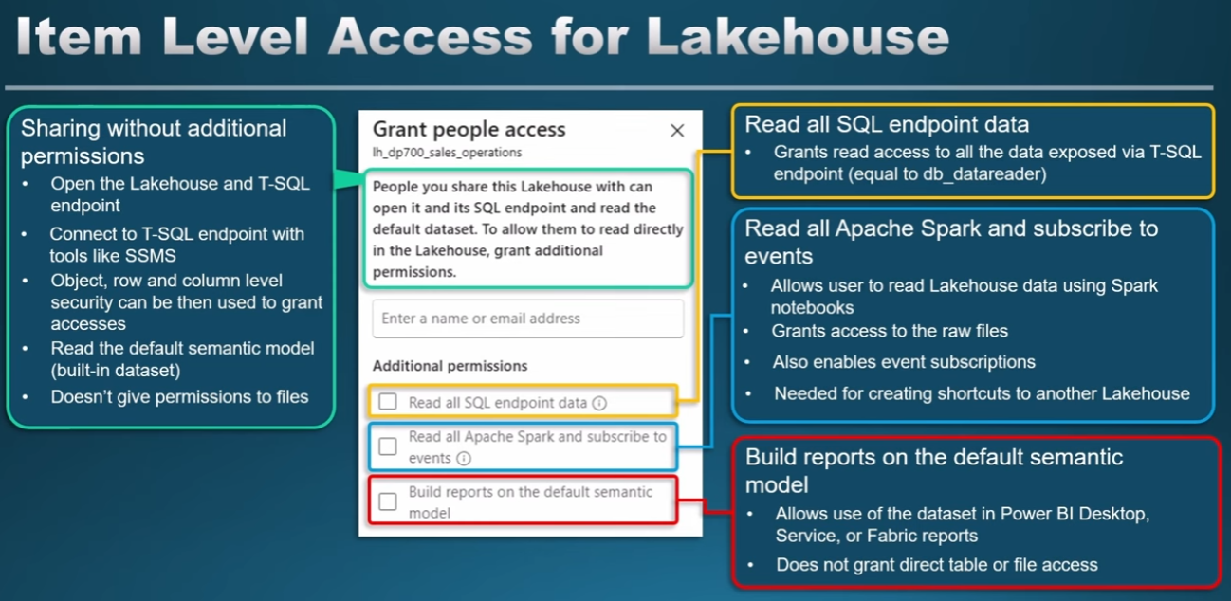
Lakehouse:

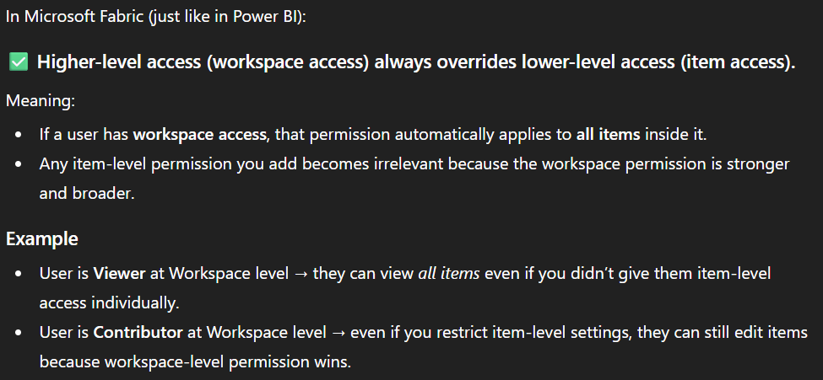
Note:

